Multiphase Reaction Engineering (MuRE -- CH3061)

Assignment 1: Fixed bed reactor

Deadline for handing in: 17-02-2026, 23:30

Over the last decade, research into sustainable energy sources has increased significantly. One of the topics that has proven to be most challenging is energy storage. From the various potential options, we will consider hydrogen storage, using ammonia as a carrier. This can done by employing the Harber-Bosch process, where hydrogen reacts with nitrogen to form ammonia. When the hydrogen is required, the reverse Harber-Bosch process can be used to decompose the ammonia back into hydrogen and nitrogen again:

2NH₃ à 3H₂ + N₂

In this assignment we will model the decomposition of ammonia in a fixed bed reactor, filled with a quartz catalyst. A python script will be developed to numerically solve the concentration profiles in the bulk phase and on the catalyst surface.

As a base case, the reaction is ran in a reactor at 1 atm and 920 K with an initial flow of NH₃ = 40 mol/s. Under these conditions, the reaction follows first order kinetics. Pressure and temperature can be assumed to be constant, effectiveness factor can be assumed equal to 1, and axial dispersion can be neglected. Needed constants are provided at the end of the assignment.

- To design a reactor that can provide the desired conversion, the packing density of the particles needs to be known. To determine this, experiments were performed where a column was filled with the selected catalyst (d_{p}=910µm). Water (µ = 1.0·10⁻³ Pa·s) was pumped through the column with a velocity of 1.0 cm/s and the differential pressure was measured at several locations in the column. Based on the obtained results (Fig.1), find the solid fraction of the catalyst particles.
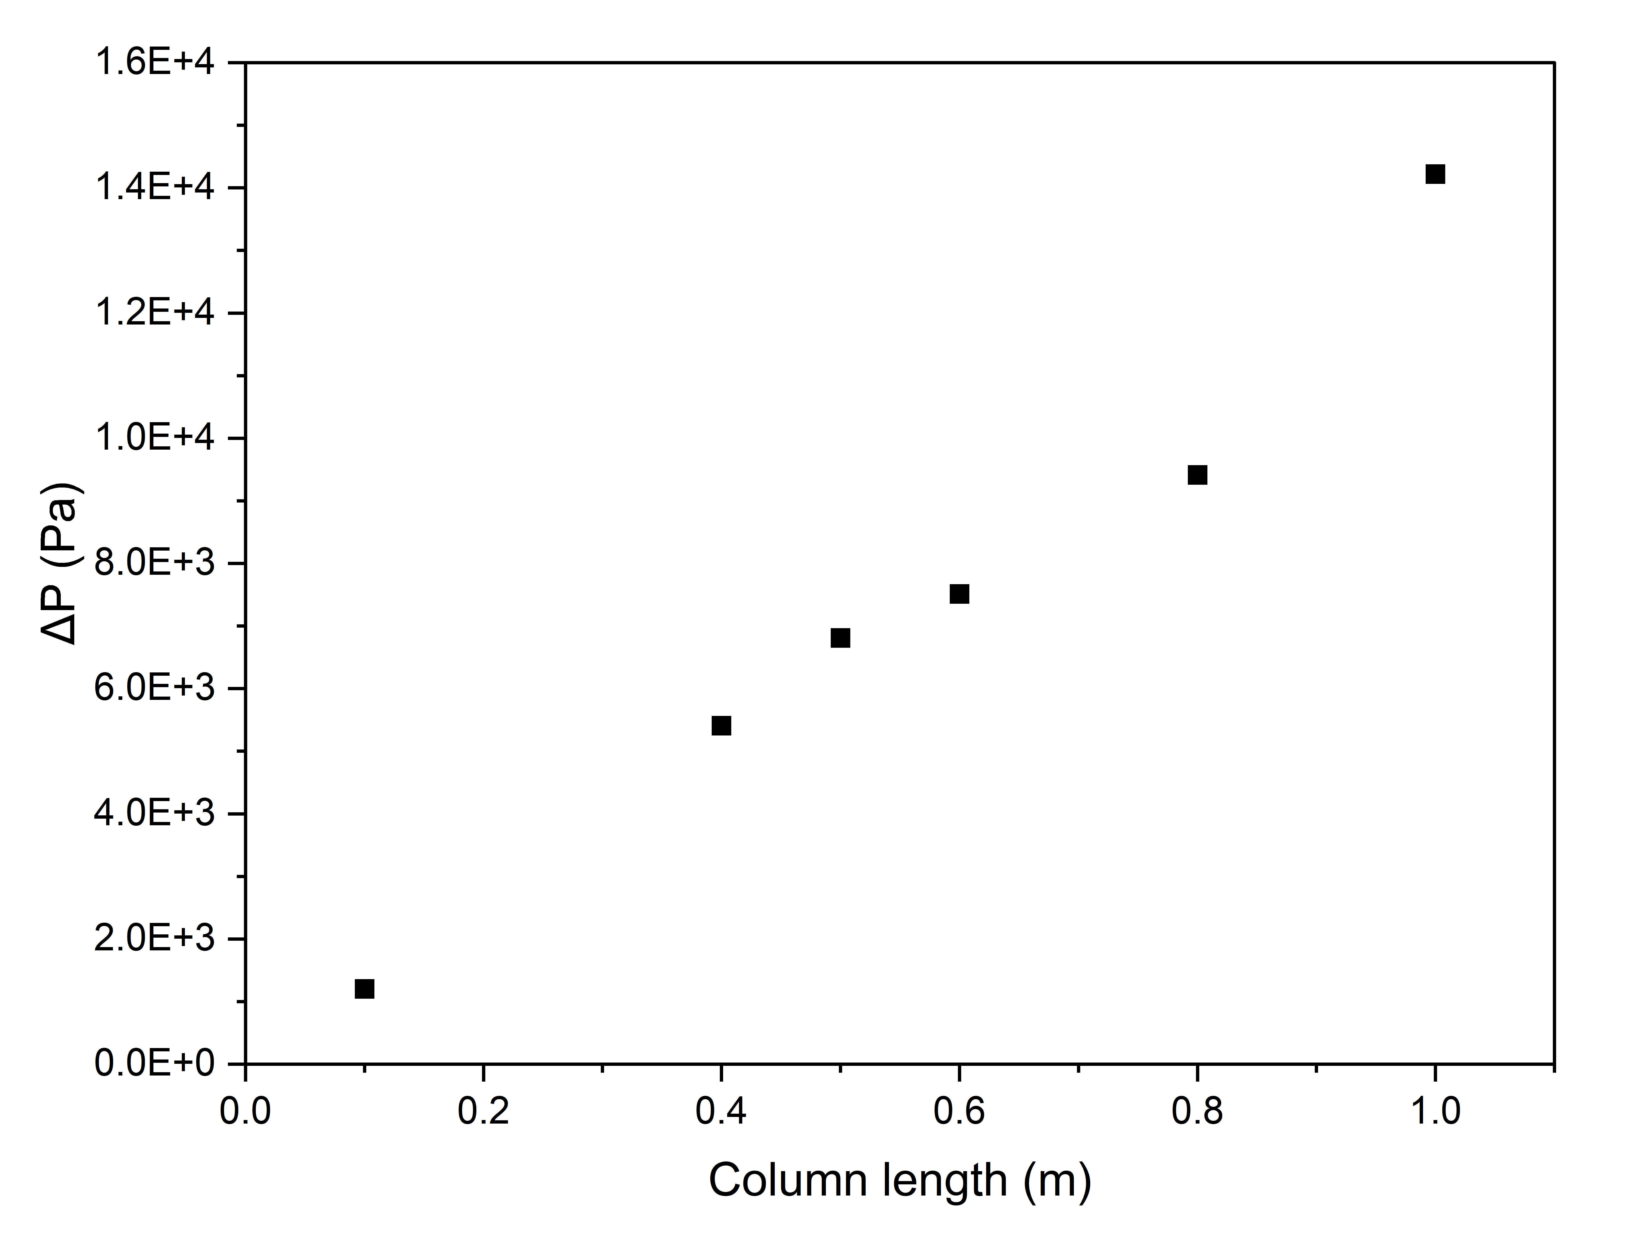
Figure 1

- Set up a mass balance over a single catalyst particle, and give an expression of the surface concentration as a function of bulk concentration. Additionally, perform a sensitivity analyses for k_{f} and K1, explain the resulting trends.

- Using the equation obtained in b, give the mass balance for each species in the bulk phase of the reactor

- Use the equations and provided constants in the python script to calculate the reactor amount of catalyst required to reach 90% conversion of NH_{3.} Provide plots of the concentration profiles of all species with respect to catalyst weight. Additionally, provide the total required reactor volume.

- The reverse Haber-Bosch process is endothermic (ΔH= 40.9 kJ/mol_{NH3}). To provide the reaction heat, a heating jacket is employed, evenly heating the reactor wall. Provided the jacket can maintain a wall temperature of 1010K, calculate the dimensions of the reactor column.

We expect you to present your findings in a report, please be sure to check Brightspace for the report requirements.

Hours spend on the assignment
Finally, indicate in your report for all individual group members how many hours each of you spend on this assignment.

NB: do not forget to upload your .py file to BrightSpace

Constants:
R = 8.31441 # Universal gas constant, J/(mol K)
rhocat = 915 # Density of the catalyst particle, kg_{cat}/m3
dp = 910e-6 # Particle diameter, m
K1 = 9.6e-4 # rate constant of reaction, m3/(kg_{cat} s)
kf = 2.45e-4 # mass transfer coefficient, m/s
P = 1.01e5 # Total pressure, Pa
Tin = 920 # Temperature, K
U = 200 # Overall heat transfer coefficient, W/(m2K)
dH = 40.9 #Enthalpy of reaction kJ/mol

